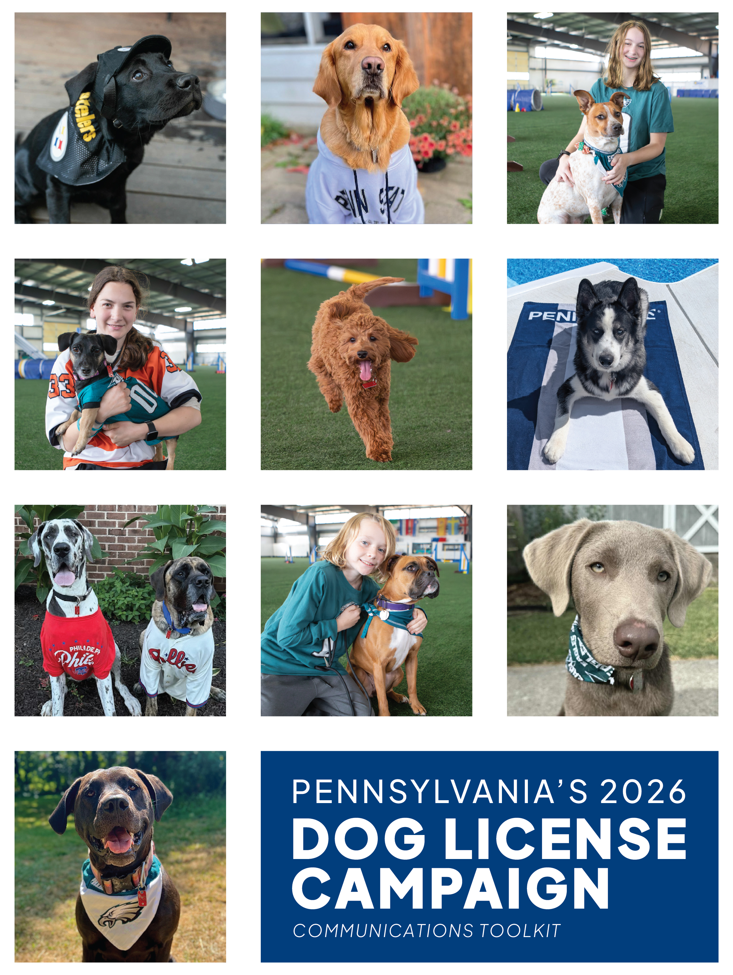

SHOW US YOUR CHAMPIONS
Pennsylvania is a place where people show up — for our families, our pets, our neighborhoods, and for the teams we love.
From the Steelers to the Eagles, the Penguins to the Phillies, to our high school teams and youth leagues, we know what it means to support a team with heart.
The Love Your Dog, License Your Dog campaign invites Pennsylvanians to celebrate their pups as the true champions of their homes — and to join the team who helps protect dogs across the Commonwealth.
Licensing your dog is more than a tag. It’s a symbol of love, responsibility, and being a good neighbor. It funds the statewide safety system — dog wardens, kennel inspectors, shelter reimbursements, disease control, dangerous dog monitoring, and anti–puppy mill enforcement —that protects every dog, not just the ones who have devoted families.
And together, we cheer on our champions — proudly wearing their 2026 license tags and team colors.
Safety Is a Team Sport.
Why Licensing Matters
We know: many modern dog owners use tags, microchips, GPS collars, and other ways to keep tabs on their pup. But keeping track of your dog’s location isn’t the only way of keeping them safe. A dog license protects your pup and your family from dangerous dogs, and it helps protect the pups who don’t have someone cheering for them.
Licensing your dog:
- Protects your pet if they get lost
- Supports statewide animal safety operations
- Helps shut down illegal kennels & puppy mills
- Prevents the spread of infectious & contagious diseases
- Reimburses shelters for holding stray dogs
- Reimburses farmers for livestock losses from dogs or coyotes
- Ensures dangerous dogs are tracked and monitored
- Keeps neighbors safer and communities healthier
Your dog has you. Some dogs only have the system your license helps fund.
For $10.80 — or $8.80 for seniors and residents with disabilities — responsible dog owners help maintain the safety net that protects Pennsylvanians millions of dogs and communities every single day.
#ShowUsYourChampions
Pennsylvania is full of loyal fans – and loyal dog lovers. This campaign brings those passions together by celebrating dogs as the MVPs of our homes and communities.
Dog owners are invited to post photos of their licensed pups sporting their dog license tags and their favorite team colors.
This transforms licensing into:
- A fun, sharable moment
- A show of pride
- A symbol of responsible dog parenting
- A way to uplift local communities
Show us your champion.
Show us your Pennsylvania pride.
Show us your love – by licensing your dog.
Teamwork and Community
County treasurers, shelters, veterinarians, dog wardens, and dog owners — we’re all on the same roster. Every licensed dog strengthens that team and helps us protect animals statewide.
Taglines
- In PA, safety is a team sport — and licensing your dog is how you get in the game.
- Your dog is the MVP of your home — protect them with a 2026 license.
- A licensed dog is a safe dog. A licensed dog is a loved dog.
- Show us your champions — and show us your Pennsylvania pride.
- Let’s bring our game-day energy into protecting our pets.
- A license is love in action
Localizable Add-Ons
- Here in [COUNTY], we support our teams with pride — and we support our dogs with that same commitment.
- Let’s make [CITY/COUNTY] a leader in responsible pet ownership.
- We’re inviting local high school, college, and minor league teams to join us and show off their champions.
Press Event Concepts
- “Champion Dog Pep Rally” at a county courthouse or stadium concourse featuring licensed dogs, mascots, and local sports figures
- Mascot Meet & Greet: Invite local sports mascots to showcase their support for licensed pups
- Halftime Spotlight: Announce the campaign during a college, high school, or minor league game
Influencer & Sports Partnerships
- Partner with PA athletes and their pets
- Collaborate with local sports reporters and radio personalities
- Feature licensed dogs on team social channels
- Encourage local teams to host “Dog License Night”
Community Engagement Tactics
- Fan-Themed Photo Challenges: “Game Day Dog,” “Tailgate Pup,” or “Victory Pose”
- School & Youth Sports Tie-Ins: Encourage teams to nominate “Champion Dogs of the Week”
- Shelter Collaboration: Promote licensing alongside adoption events
- County Leaderboard: Track which counties have the highest percentage of licensed dogs or most “Show Us Your Champion” photos.
Social Media Content Ideas
- Short-form videos featuring dog wardens, mascots, and local pets
- Boosted posts during major PA sports events (season openers, playoffs, rivalry games)
Ready to Use Social Media Posts
Ready for you to use – just copy, paste, post!
Facebook – Show us your champion!
Post #1:
Show us your champion! 🏅 🐶
Pet safety is a team sport. Become a team player and license your dog for 2026. A dog license is the best way to protect your four-legged MVP — and it helps support the dog wardens who keep our communities safe.
Annual dog licenses cost $10.80, or $8.80 for senior citizens and residents with disabilities. Let’s keep every PA pup safe, seen, and celebrated. 🐾💛
Post a photo of your dog, wearing a PA license and favorite team colors. Drop a comment below or tag us and use #PA4Paws so we can cheer on your MVP!
Apply: http://bit.ly/PADogLicense
#LoveYourDogLicenseYourDog #PA4Paws #ShowUsYourChampions
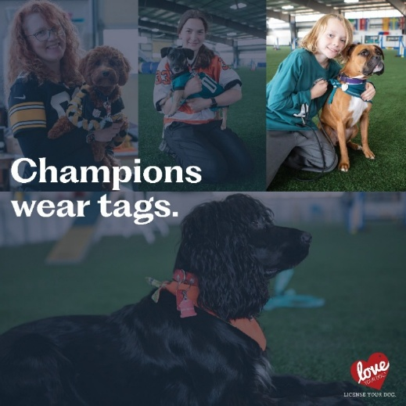
Post 2:
Your dog is already a champion at home — now make it official! 🐶✨
A 2026 dog license helps keep lost pets out of shelters, and home where they belong. Your license supports the work that keeps dogs, kennels, and communities safe.
A 2026 annual dog license costs $10.80 — or $8.80 for seniors and people with disabilities.
Post a photo of your dog, wearing a PA license and favorite team colors. Drop a comment below or tag us and use #PA4Paws so we can cheer on your MVP!
Apply: http://bit.ly/PADogLicense
#LoveYourDogLicenseYourDog #PA4Paws
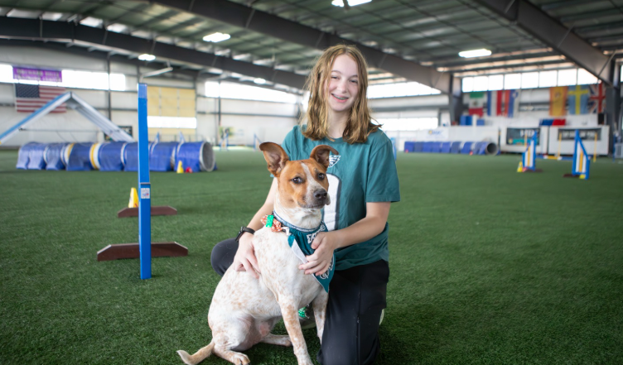
Post 3:
Are you a team player? Make it official by licensing them for 2026 – the responsible, neighborly thing to do. Your license helps protect dogs across the Commonwealth. 🐾
A 2026 annual dog license costs $10.80, with a reduced rate of $8.80 for seniors and residents with disabilities.
License your dog → keep them safe. 💛 Show Us Your Champion!
Apply: http://bit.ly/PADogLicense

Facebook – What does Dog License funding support
Post 1:
When you license your dog, you’re doing more than following the law — you’re protecting dogs and entire communities.
🐾 Revenue from dog license sales funds the work of Pennsylvania’s dog wardens, who:
• Inspect 2,500+ state-licensed kennels at least twice a year and make animal cruelty referrals.
• Shut down illegal kennels and puppy mills
• Monitor 700+ dangerous dogs
• Pick up stray or abandoned dogs and get them home or to a safe shelter
• Help stop the spread of infectious & contagious diseases
• Reimburse shelters that hold stray dogs
• Reimburse farmers for livestock losses caused by dogs and coyotes
Licensing your dog keeps all dogs safer — including yours.
Apply: http://bit.ly/PADogLicense
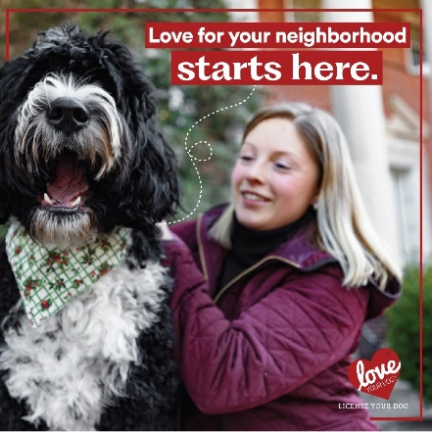
Post 2:
When you license your dog, you’re doing more than protecting your own pup – you’re supporting the entire community.
Revenue from dog license sales funds the work of Pennsylvania’s dog wardens, who:
🐾 Inspect 2,500+ state-licensed kennels at least twice a year and make animal cruelty referrals
🐾 Shut down illegal kennels and puppy mills
🐾 Monitor 800+ dangerous dogs
🐾 Pick up stray or abandoned dogs and get them home or to a safe shelter
🐾 Help stop the spread of infectious & contagious diseases
🐾 Reimburse shelters that hold stray dogs
🐾 Reimburse farmers for livestock losses caused by dogs and coyotes
Licensing your dog keeps all dogs safer – including yours.
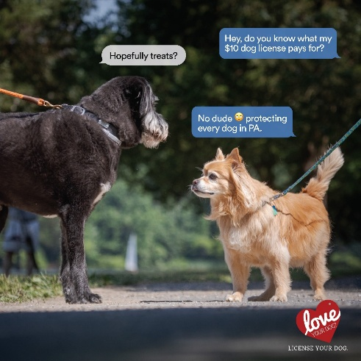
Apply: http://bit.ly/PADogLicense

Post 3:
A dog license does more than get a lost pup home. It powers the work that keeps our communities safe.
These funds help PA dog wardens:
- Shut down puppy mills
- Inspect kennels to protect dogs and puppies
- Monitor dangerous dogs
- Prevent the spread of infectious & contagious diseases
- Support shelters, farmers, and communities
Your dog license helps protect dogs across Pennsylvania — every single day.
Apply: http://bit.ly/PADogLicense
#LoveYourDogLicenseYourDog #ProtectPADogs
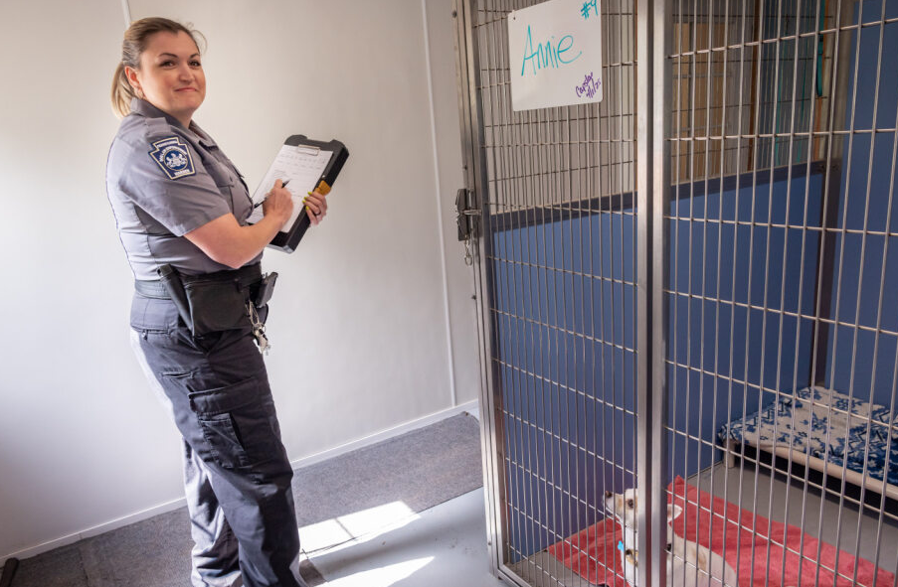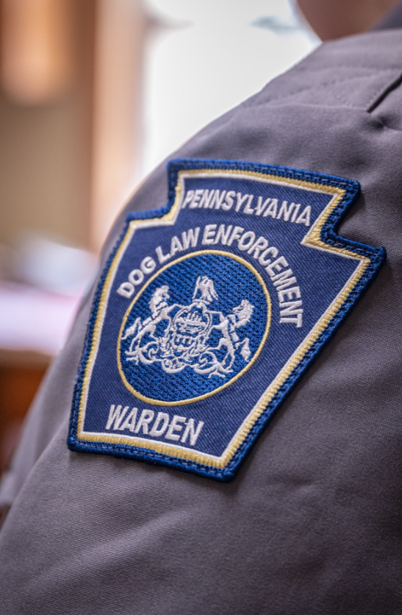
Post 4:
Dog wardens are PA’s unseen defensive line – and every licensed dog is part of the champion team keeping dogs safe.
Your 2026 license helps:
🏆 Rescue strays
🏆 Inspect kennels
🏆Stop illegal breeders
🏆 Track dangerous dogs
🏆 Prevent disease spread
🏆 Support shelters
License your dog.
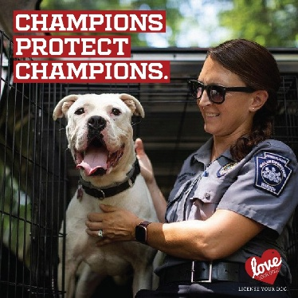
Post 5:
When you buy a dog license, you’re standing up for dogs who can’t speak for themselves.
Your support helps dog wardens:
- Shut down puppy mills
- Pick up and protect stray dogs
- Track dangerous dogs
- Control the spread of infectious & contagious diseases
- Keep dogs housed in 2,500+ kennels safe and monitored
- Support farmers impacted by dog or coyote caused damages to livestock
One license makes a difference statewide.
Apply: http://bit.ly/PADogLicense
#LoveYourDogLicenseYourDog #ProtectPADogs
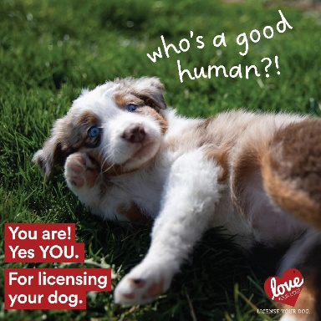
X (Twitter) - Show Us Your Champion
Post 1:
Show us your champion! 🐶🏅 Become a team player and license your dog for 2026. Keep your pup protected & support PA dog wardens.
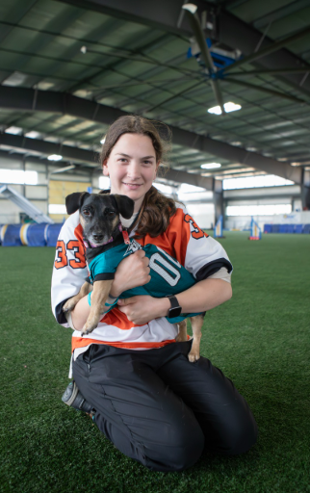

Post 2:
Show us your champion! License your dog for 2026 and keep them safe all year long. 🐾
Post 3:
Your pup’s a champion — make it official! 🐶✨ License your dog for 2026 and help keep pets and communities safe.
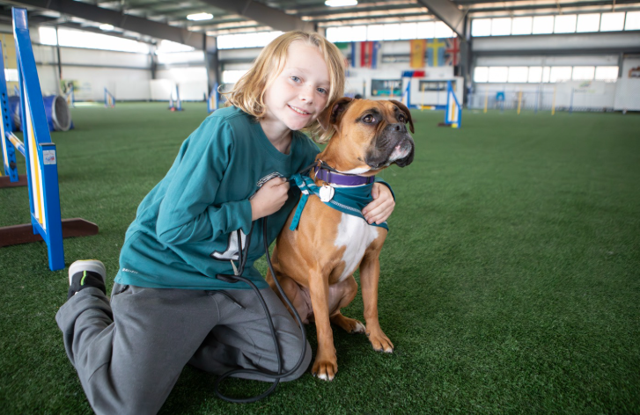
X (Twitter) - What does Dog License funding support
Post #1:
Licensing your dog protects pups statewide. It funds kennel inspections, shuts down puppy mills, helps strays & tracks dangerous dogs. Apply: http://bit.ly/PADogLicense
#ProtectPADogs
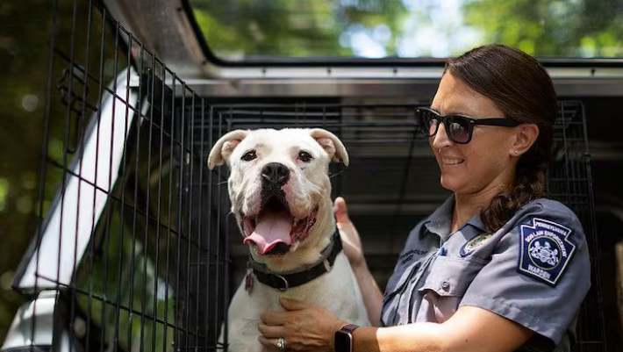

Post #2:
A dog license keeps communities safe—shutting down on puppy mills, protecting dogs housed in kennels, preventing the spread of infectious & contagious diseases & supporting shelters that take in stray dogs.
Apply: http://bit.ly/PADogLicense
Post #3:
A dog license protects dogs who can’t speak for themselves—shutting down puppy mills, helping strays & monitoring dangerous dogs.
Apply: http://bit.ly/PADogLicense
#LoveYourDogLicenseYourDog #ProtectPADogs
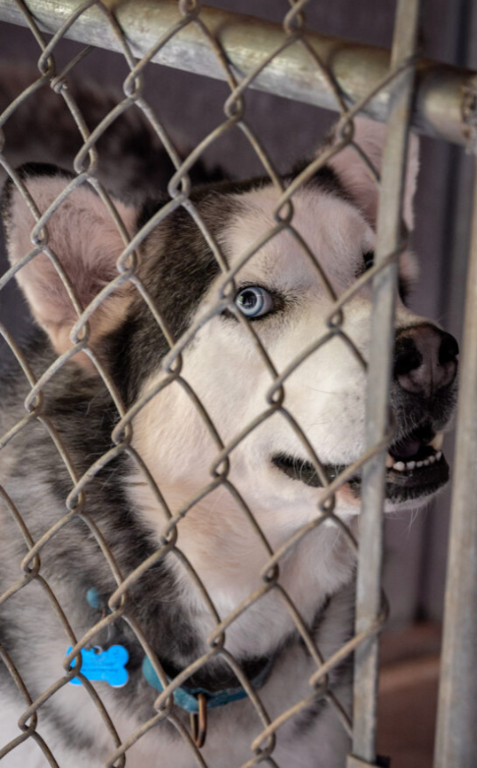
Licenses are the Law
X Post
A dog license is your pet’s fastest ticket home — and it’s the law.
Failing to license your dog can lead to fines up to $500 + court costs, but a simple, visible tag can make all the difference if they ever get lost.
http://bit.ly/PADogLicense

X Post
Last year, only 3% of stray dogs in PA were immediately reunited with their owners, and 23% had to be sent to shelters outside their home county due to limited space.
Protect your dog. Protect your community.
License your dog today.
http://bit.ly/PADogLicense
Facebook/LinkedIn Post #1
Keeping your dog licensed keeps them protected — and it protects your wallet, too.
The cost of a dog license is far less than the penalty for being caught without one. Owners who fail to license their dogs can face fines of up to $500 plus court costs per unlicensed dog.
Licensing also helps lost pets get home faster. Last year, only 3% of stray dogs in Pennsylvania could be immediately returned to their owners, and 23% had to be transported to shelters in other counties due to limited space.
A license is visible to anyone who finds your dog — a microchip isn’t.
Keep your dog safe. Keep them licensed.
http://bit.ly/PADogLicense

Facebook/LinkedIn Post #2
Keep your dog safe — and protect your wallet. A dog license costs far less than the $500 fine + court costs you could face for not having one.
Licensing also brings lost pets home faster. Last year, only 3% of stray dogs in PA were immediately reunited with their owners, and 23% had to be sent to shelters in other counties because local space was full.
A license is easy to spot. A microchip isn’t.
Give your dog the protection they deserve. Keep them licensed.
http://bit.ly/PADogLicense

Sample Content for Newsletters and Websites
License Your Dog in PA
In Pennsylvania, all dogs must be licensed at point of purchase or adoption (earliest is 8 weeks of age) or by 3 months if no transfer of ownership has occurred. All dogs that do not have a lifetime license must be licensed by Jan. 1 of each year.
For 2026, an annual license is $10.80, and a lifetime license is $52.80. Discounts are available to older adults and people with disabilities.
The small license fee helps protect the millions of dogs across the state, the families who adopt or purchase them, and the communities they live in by funding the important work of the Pennsylvania Department of Agriculture Bureau of Dog Law Enforcement.
Dog licenses are available from your local county treasurer and other licensing agents.
Reasons for dog licensing:
- It’s the law. All dogs must have a license when they are purchased or adopted.
- If your dog gets lost, a license is the best way to get him back. A license helps animal control and shelters identify your dog and get him back home safely.
- The cost of a license is less than the penalty for being caught without one. Owners who fail to license their dogs could face a fine of up to $500, plus court costs, for each unlicensed dog.
- License fees support animal control. The annual fee you pay to license your dog helps keep shelters running and supports the work of the Bureau of Dog Law Enforcement, which is responsible for ensuring the welfare of dogs, regulating dangerous dogs and overseeing annual licensing and rabies vaccinations.

Sample News Release
FOR IMMEDIATE RELEASE
December XX, 2025
MEDIA CONTACT: [Contact person for the county treasurer’s office]
Protect Your Dog with a 2026 Dog License, Available Online from Your County Treasurer
Buy an annual license online by clicking on your county at licenseyourdogpa.pa.gov. The deadline to purchase a 2026 license is January 1, 2026.
<<CITY>>, PA – Pennsylvanians can now purchase 2026 dog licenses online from their county treasurers. State law now requires all dogs to be licensed at the point of purchase or adoption. Licenses are not just a legal responsibility of owning a dog in Pennsylvania, sales of dog licenses fund dog wardens’ work to protect all Pennsylvania dogs and the communities they live in. Online purchasing is now available, just click your county on the map at www.licenseyourdogpa.pa.gov.
Insert a quote from the county treasurer about how licenses help your county.
An annual dog license is $10.80. Lifetime licenses are available for $52.80 for dogs with permanent identification like a microchip or tattoo. Senior adults and people with disabilities are eligible for discounted fees of $8.80 for an annual license or $36.80 for a lifetime license.
Unlike a chip, which is invisible without an electronic reader, a license on a dog’s collar is clearly visible and increases their chance of being returned home, rather than ending up in a shelter. In 2024, only 3% of stray dogs across Pennsylvania could immediately be returned to their owners, and 23% were taken to shelters in other counties, due to lack of shelter space in the county where they were found.
The dog license application is simple. It requires owner contact information and the dog’s name, age, breed, and color.
[Insert name of county treasurer] offered these benefits of licensing your dog:
- A license is the best way to get your dog back if they get lost. A license helps animal control and shelters identify a dog and its rightful owners.
- The cost of a license is far less than the penalty for being caught without one. Owners who fail to license their dogs can face fines of up to $500, plus court costs, for each unlicensed dog.
- License fees support animal control and public safety. Dog license fees help keep shelters running and support the Pennsylvania Department of Agriculture’s Bureau of Dog Law Enforcement’s vital services to protect dogs and the public. This year, the Bureau of Dog Law Enforcement:
  - Enforced health and safety regulations, upholding Pennsylvania’s high standards for conditions in kennels by licensing nearly 2,800 operations and conducting more than 5,500 inspections annually.
  - Revoked or refused licenses to 10 kennels, some of which were on the Humane Society of the U.S. puppy mill list. Issued 36 civil penalties to illegal kennel and advertising violators, and as the eyes in PA licensed kennels made dozens of referrals for animal cruelty investigations.
  - Tracked and monitored 826 dogs deemed dangerous by magisterial judges, helping to ensure that dog owners keep dangerous dogs under control and the community safe.

For more information, contact <<INSERT COUNTY NAME>> County Treasurer <<INSERT TREASURER’S NAME>> at <<INSERT PHONE NUMBER AND/OR EMAIL ADDRESS>>. To buy an annual license online, learn how to buy a lifetime license, or find your treasurer or dog warden, visit www.licenseyourdogPA.com or call the Department of Agriculture’s Bureau of Dog Law Enforcement Office at 717-787-3062.

THEMED PRESS RELEASE
FOR IMMEDIATE RELEASE
December XX, 2025
MEDIA CONTACT: [Contact person for the county treasurer’s office]
Protect Your Dog with a 2026 Dog License — and Show Us Your Champions
Licenses available online through your county treasurer
Buy an annual license online by clicking on your county at licenseyourdogpa.pa.gov. The deadline to purchase a 2026 license is January 1, 2026.
CITY, PA – Pennsylvanians can now purchase 2026 dog licenses online from their county treasurers — and this year, we’re celebrating the MVPs who matter most at home. Through the statewide “Show Us Your Champions” campaign, dog owners are invited to license their pups and share photos of them wearing their favorite team’s colors. Because in Pennsylvania, safety is a team sport — and every dog is part of the lineup.
State law now requires all dogs to be licensed at the point of purchase or adoption. Licensing is more than a legal responsibility — it is how we fund the safety network that protects dogs across Pennsylvania. With online purchasing now available, Pennsylvanians can get in the game and license their champions by clicking their county at www.licenseyourdogpa.pa.gov.
Insert quote from county treasurer, ideally tying licensing to community safety and county pride in local “champion” pets.
An annual dog license is $10.80. Lifetime licenses are available for $52.80 for dogs with a microchip or tattoo. Senior adults and people with disabilities receive discounted rates of $8.80 annually or $36.80 for a lifetime license.
A license is like a team badge — instantly visible on a dog’s collar and crucial for getting lost pets home. Unlike a microchip, which requires special equipment to detect, a license can reunite a dog with its family immediately. In 2024, only 3% of stray dogs across Pennsylvania could be returned home right away, and 23% had to be transported to shelters in other counties due to limited local space. A license helps prevent that.
The license application is simple and requires basic owner contact information and the dog’s name, age, breed, and color.
Insert name of county treasurer highlighted the importance of licensing, noting that it helps keep both dogs and communities safe:
• A license is the fastest way to bring a lost dog home. It helps animal control and shelters identify dogs and contact rightful owners.
• Licensing avoids steep penalties. Dog owners can face fines up to $500 plus court costs for each unlicensed dog.
• License fees keep Pennsylvania’s dog safety system strong. Fees fund shelters and the Pennsylvania Department of Agriculture’s Bureau of Dog Law Enforcement — the statewide team responsible for protecting dogs and communities. This year, the Bureau:
- Licensed 2,777 kennels and conducted more than 5,500 inspections.
- Revoked or refused 10 kennel licenses, including some on national puppy mill lists; issued 36 civil penalties; and made dozens of animal cruelty referrals.
- Monitored 826 dangerous dogs, ensuring owners comply with strict safety requirements.
Pennsylvanians are encouraged to post photos of their licensed dogs showing off team pride using #ShowUsYourChampions. Whether they’re cheering for the Birds, the Steelers, the Pens, the Phillies, or their local high school team, every licensed pup is an MVP helping keep Pennsylvania’s pet safety team strong.
For more information on how to get in the game, contact <> County Treasurer <<INSERT TREASURER’S NAME>> at <<INSERT PHONE NUMBER AND/OR EMAIL ADDRESS>>.
For more information, contact <<INSERT COUNTY NAME>> County Treasurer <<INSERT TREASURER’S NAME>> at <<INSERT PHONE NUMBER AND/OR EMAIL ADDRESS>>. To buy an annual license online, learn how to buy a lifetime license, or find your treasurer or dog warden, visit www.licenseyourdogPA.com or call the Department of Agriculture’s Bureau of Dog Law Enforcement Office at 717-787-3062.

General Information and Background
Bureau of Dog Law Enforcement – Keeping Pennsylvania Safe for Dogs AND Humans
The Bureau of Dog Law Enforcement is responsible for ensuring the welfare of dogs and puppies in licensed kennels. The bureau oversees annual licensure and rabies vaccinations for dogs and regulates activities tied to dogs that district courts have classified as dangerous. Our state dog wardens:
- Enforce licensing and rabies laws.
- Seize and detain dogs running at large without an owner.
- Investigate dog bites. Establish and enforce quarantine of dogs.
- Enforce kennel licensing and regulations through at least two annual inspections of every licensed kennel.
- Prosecute dog law violations criminally and civilly.
- Maintain a registry of dogs declared dangerous by a magisterial district judge.
- Conduct inspections to ensure dangerous dog owners are meeting their legal responsibilities.
- Provide educational services about responsibilities of dog ownership.

License Your Dog. It’s the law, and it’s the best way to bring your pet home if they get lost:
- All dogs must be licensed at point of purchase or adoption (earliest is 8 weeks of age) or by 3 months if no transfer of ownership has occurred. All dogs must have a current annual by Jan. 1 of each year unless the dog has a lifetime license.
- Owners of unlicensed dogs can be cited with a maximum fine of $500 per dog, plus court costs.
- Dog wardens check neighborhoods to ensure all dogs are licensed. Violators may be fined.
- If your dog gets lost, a current license is the fastest way to get your dog back home instead of ending up in a shelter. Even if your dog has a chip, a license is visible. A chip is not.
- In 2024, only 3% of stray dogs across Pennsylvania could immediately be returned to their owners, and 23% were taken to shelters in other counties, due to lack of shelter space in the county where they were found.
- Licensing fees help the millions of dogs in Pennsylvania by funding the Bureau of Dog Law Enforcement’s work to uphold animal welfare and public safety standards.
- Purchase a license from your county treasurer or issuing agent.
- An annual license costs $10.80. Lifetime licenses are available for $52.80 for dogs with permanent identification like a microchip or tattoo. Senior adults and people with disabilities may be eligible for discounted fees of $8.80 for an annual license or $36.80 for a lifetime license.

Pennsylvania’s Dog Law Summary:
- Your dog must be under control and supervised at all times. You are responsible for any damages your dog causes on someone else’s property.
- It is illegal to mistreat or abuse animals. Report suspected abuse to your local humane organization or police.
- Intentionally poisoning a dog is illegal, whether it is yours or someone else’s.
- You may not abandon or attempt to abandon any dog. You could be fined $1,000 plus court costs.
- Puppies less than eight weeks old cannot be bartered, traded, sold, or transferred.
- You must have a kennel license if you keep, sell, transfer, adopt, or foster at least 26 dogs in a calendar year.
- If your dog attacks or kills a human or domestic animal without provocation, the dog may be considered dangerous. You may face extensive fines and restrictions.

New legal requirements include:
- Kennels selling or offering dogs for sale or adoption are required to provide a dog license application and brochure at time of transfer of ownership.
- Annual registration for harboring a dangerous dog is $1,000 for any dog deemed dangerous by district courts.
- Owners of dogs that attack again after having been declared dangerous are required to find and pay a kennel to house the dog during court proceedings. This is to ensure the community remains safe until a final determination is made.
- Kennels and shelters that offer dogs for sale or adoption must include their kennel name, kennel address, and kennel license number in all advertisements.
- Kennels selling or adopting dogs at retail to the public are responsible for disclosing breeder information, vaccination and medical documentation, and any known bite attacks to perspective customers.

Pennsylvania’s Rabies Law:
Ignoring Pennsylvania’s rabies vaccination law can be costly — in more ways than one. Dogs can be exposed to the rabies virus through wild and stray animals, threatening their health and yours.
- Dogs three months or older must have a current rabies vaccination.
- Owners of unvaccinated pets may be fined up to $300 plus court costs.
- Licensed veterinarians can vaccinate dogs and provide a vaccination certificate.
- Dog wardens perform random checks to ensure rabies vaccinations are current.

